‘Car Reatailor Project Database’

By Eng. Hamzah, Eng. Mostafa

Dr Omar Shalash, Eng. Salma Mahmood

DEC 21, 2022

The Main idea
The main idea of this project is to make a ‘Car retailor’ database for a company. The company has cars and customers that will buy a certain car of their choice. However that’s not it…! We need to take into consideration that there will be employees, sponsors, shipments and ect…
First, lets make an ER Diagram:
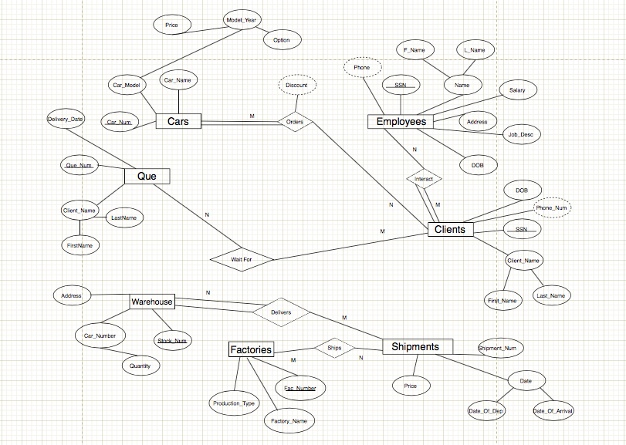

The Implementation
First we will create the tables. When creating the tables, we will need to know the primary keys and data types for each attribute. Then we will insert values into the table. When doing the ER diagram, we have distinguished the realtion ship types (all of them were many to many relationships), to identify the foreign keys and weather or not, we would need to make new tables.

Using phpMyAdmin, We will use SQL to implement this.

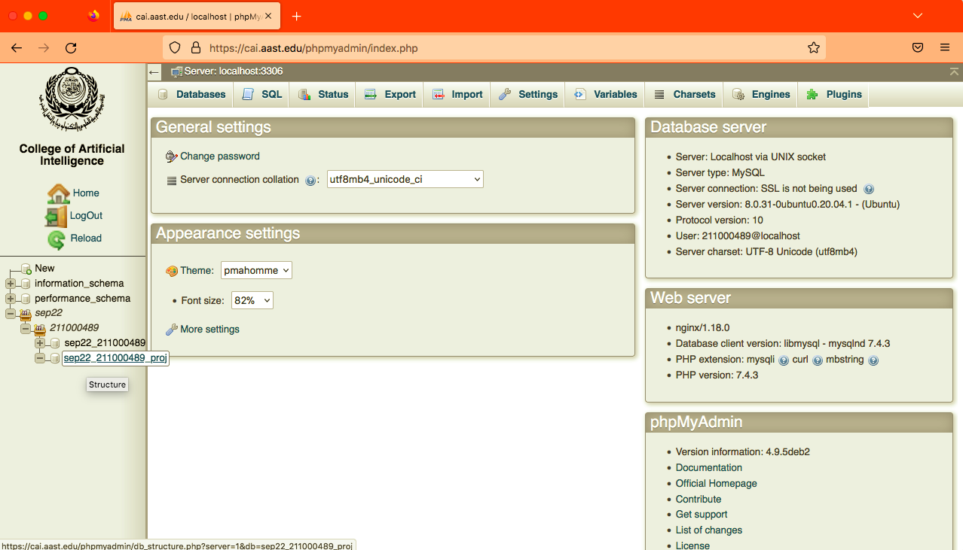

SQL Codes
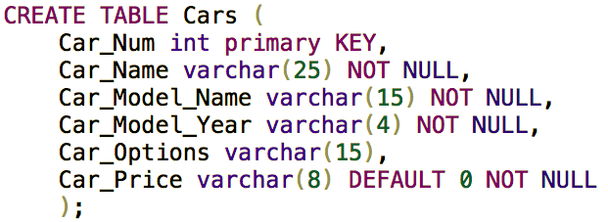
Car_Num here is our primary key. Car_Name is set varchar because it will contain a name (string) and it must be filled. Car_Model_Name such as in Mercedes have a car model named “EQS”! Car_Model_Year is set to varchar(4) because car model can be 2020, 2021, 2022 or anything else, and It has to be filled. Car_Options such as “Highline” (Full option). Other cars like Mercedes only have 1 option, therefore it can be left blanc. Car_Price is the price of the car. We used varchar instead of int because int may not include 6 figure digits. We couldn’t use money as it is not compatible with phpMyAdmin.

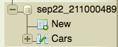

SQL Codes
When we started inserting we realised that the price may take more than 8 characters. So then we altered the table using the edit keys and clicked on save later
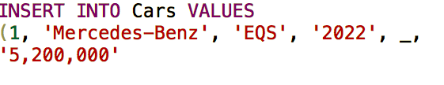
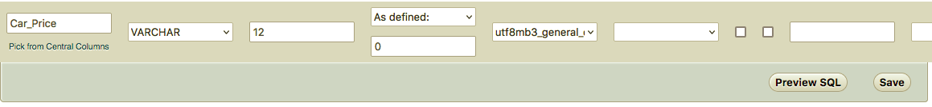

Now it is time to insert

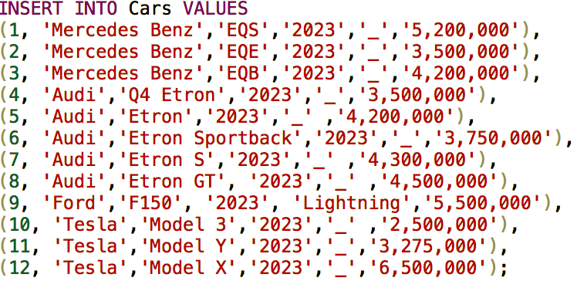

Here is the output of the code we wrote

SQL Codes

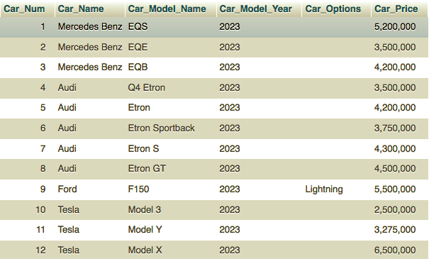

Now we will create the Employees table
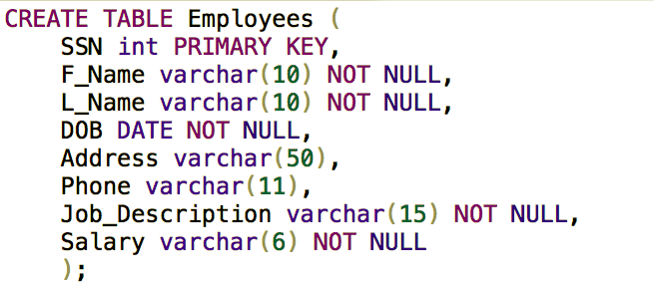
Then we will insert into the table

SQL Codes

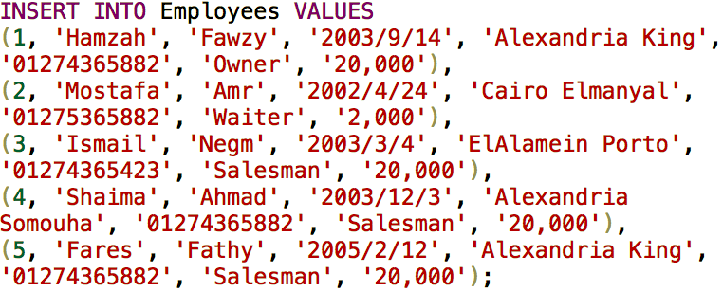

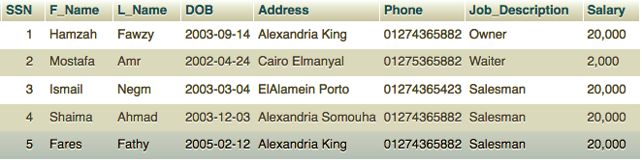
We will repeat the same process for the resto of the entities.
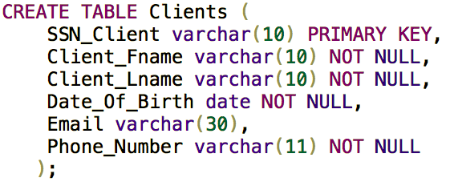

SQL Codes

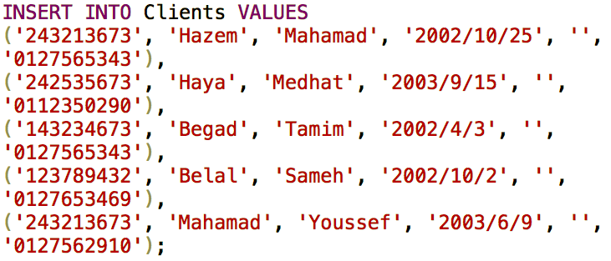
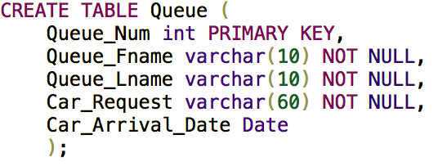
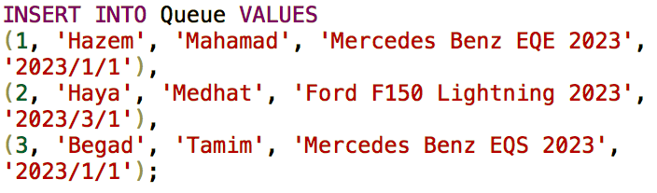
Here we forgot to add in the ‘Queue’ table to add a column named payment type whether it is cash or monthly installment. So I used alter table code.

SQL Codes
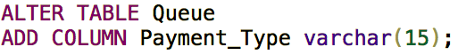
We wanted to use boolean instead of varchar but when we researched about boolean, we can only give a choice of 1 or 0, not ‘cash’ or ‘monthly installment’, therefore we used varchar.
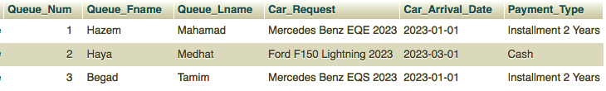
Then we created the table ‘Warehouse’
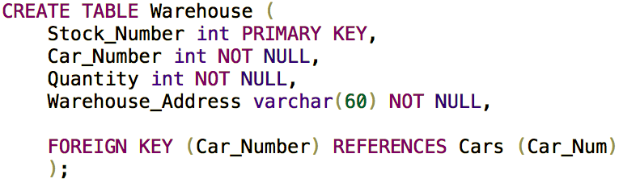
We made a foreign key for the car numbers as the car number contains all the data for the car. The ‘Warehouse’ table can function more as a ‘Stock’ Table.


SQL Codes
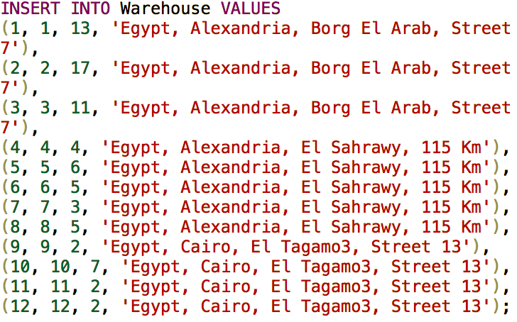
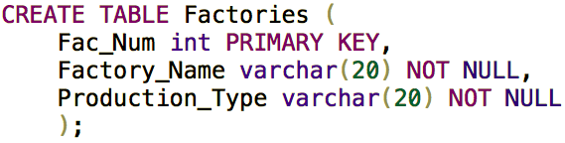
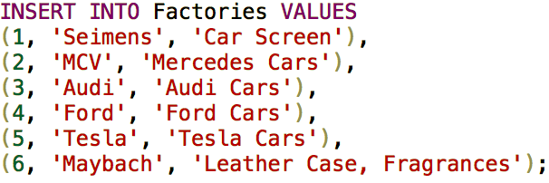

SQL Codes

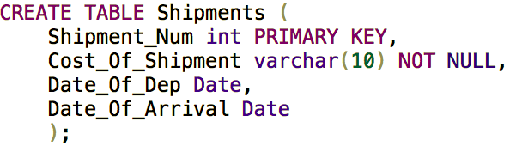
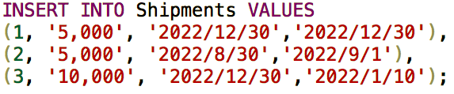

Now we have finished all the tables. We will now do the table for the relationships as every relationship, is a many to many relationship
We will start with the ‘Interacts’ relationship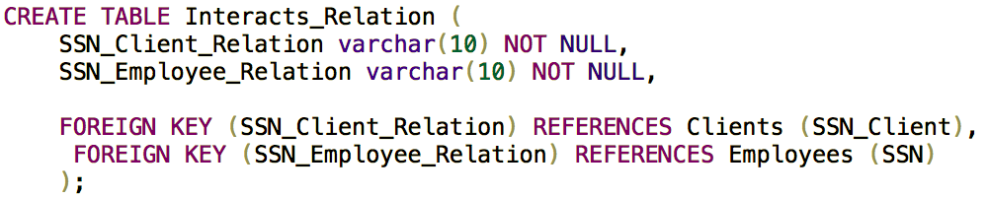

SQL Codes

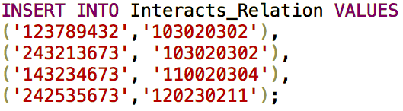

The ‘Orders’ Relationship:
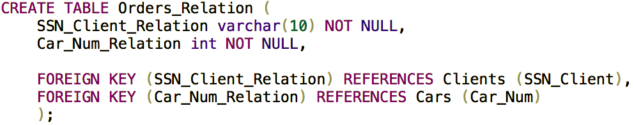
When inserting we used ‘Queue’ table to assist us in choosing the right person with their requested car.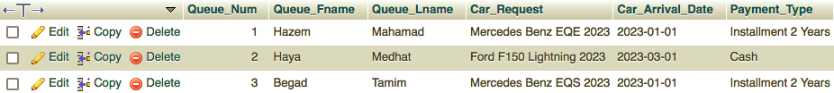
With the help of this table we were able to insert…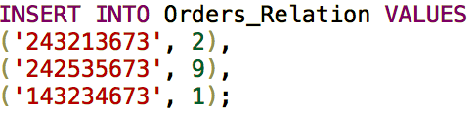
We then forgot to add discount to the relationship. So we added it

SQL Codes

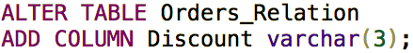
Then we moved on to the next relationship as Hazem, Haya and Begad don’t deserve a discount!
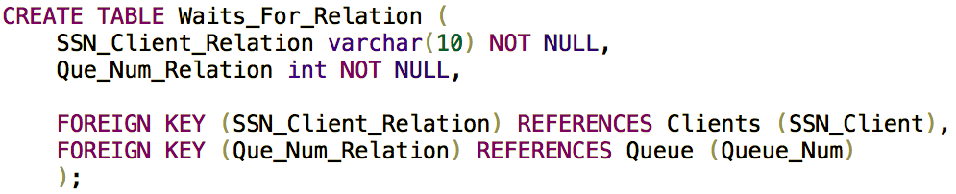
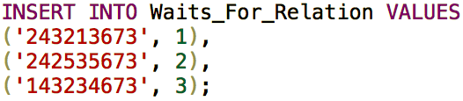

SQL Codes
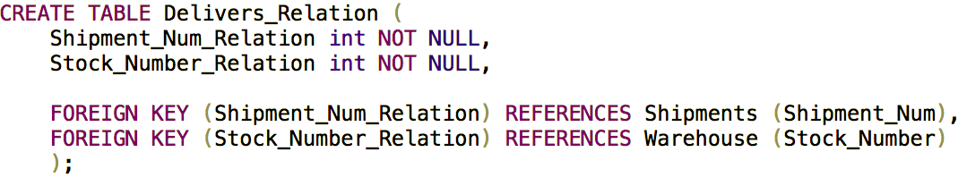
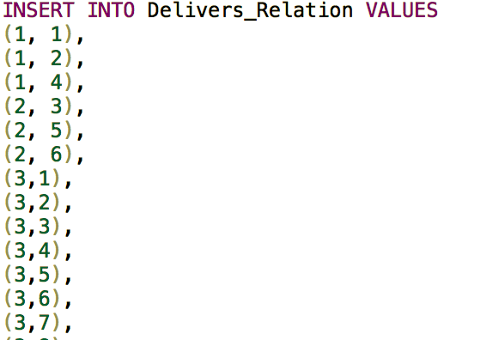

And for the final relationship!
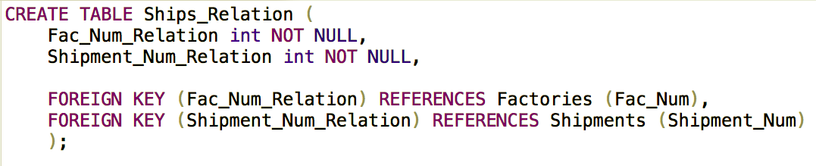

SQL Codes

